|  |  |
| --- | --- |
|  |  |

Faculty of Technology and Engineering

**Chandubhai S. Patel Institute of Technology (CSPIT)**

**Department of Computer Science & Engineering**

Date: / /

**Laboratory Manual**

|  |  |  |  |  |  |
| --- | --- | --- | --- | --- | --- |
| Academic Year | : | 2024-25 | Semester | : | 4 |
| Course code | : | CSE206 | Course name | : | DATABASE MANAGEMENT SYSTEM |

|  |
| --- |
| Practical - 8 |
| AIM - You are tasked with designing a database for managing a sales and client management system. The database should support the creation, updating, and querying of data related to salespeople, customers, orders, and clients while ensuring data integrity through constraints. (Refer the attached excel sheet for Database) |

1. Managing Salespeople Information: The organization needs a table to store data about its salespeople.Each salesperson must have a unique ID, a name, and optionally, a city and commission rate.



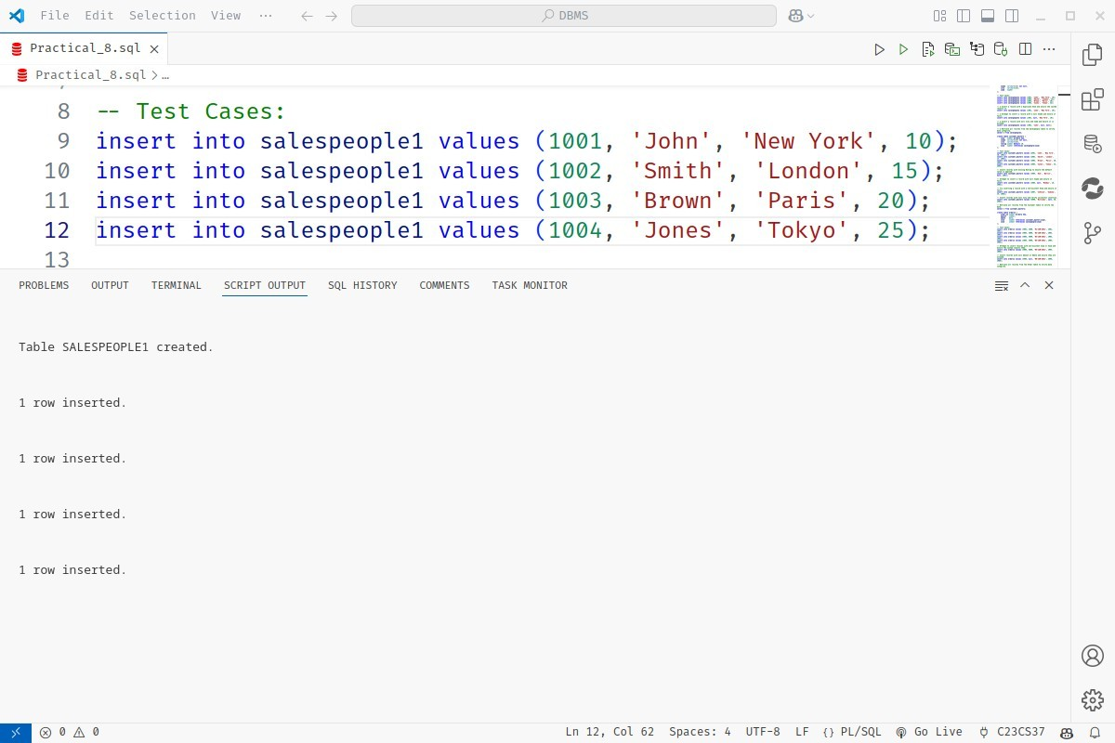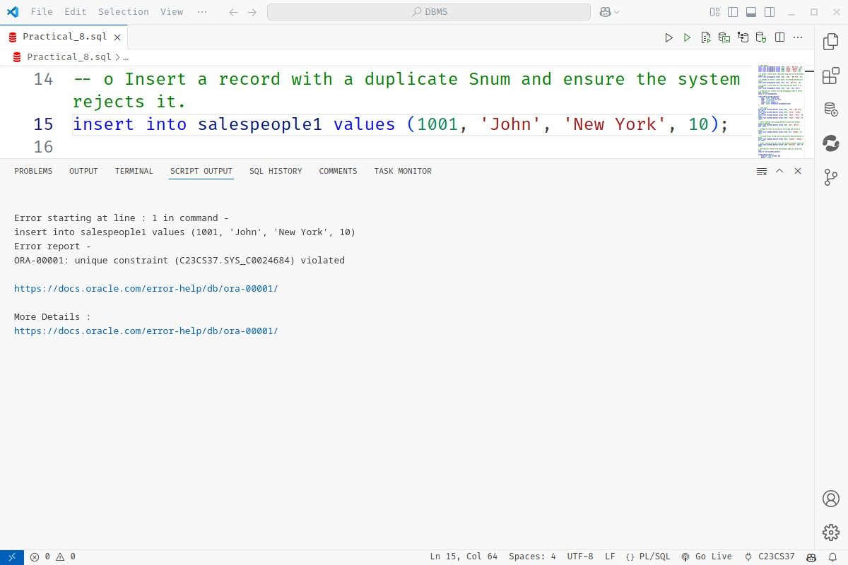



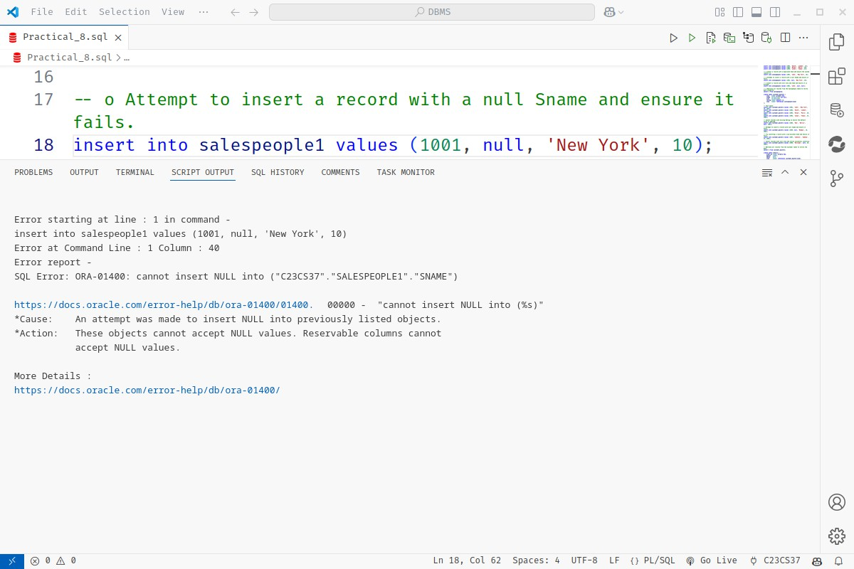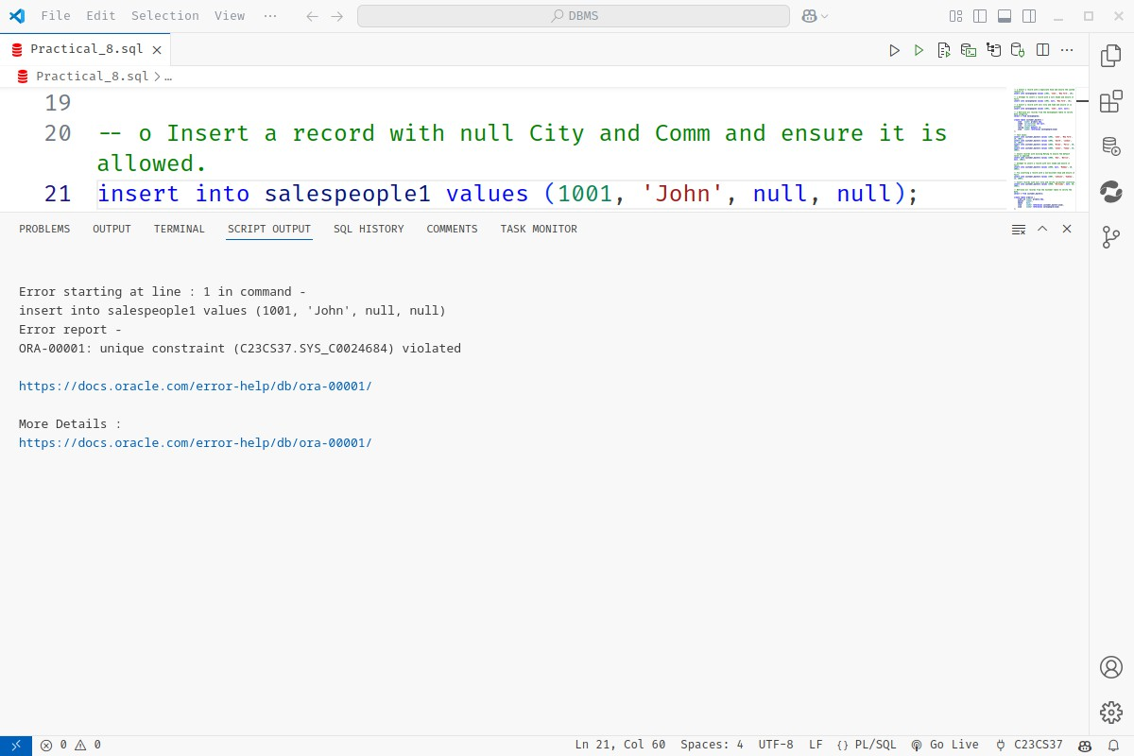

|  |
| --- |
|  |
| 2. Managing Customer Information: The system must store customer details, including their relationship with salespeople. Customers have unique IDs, names, and optionally a city. They also have a rating with a default value. |



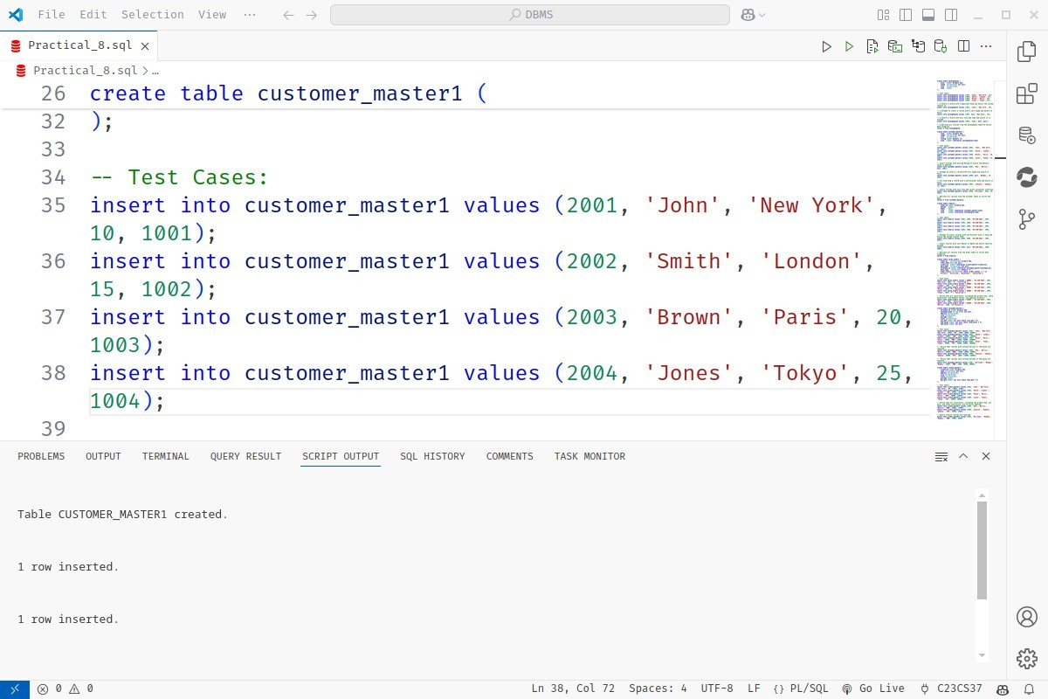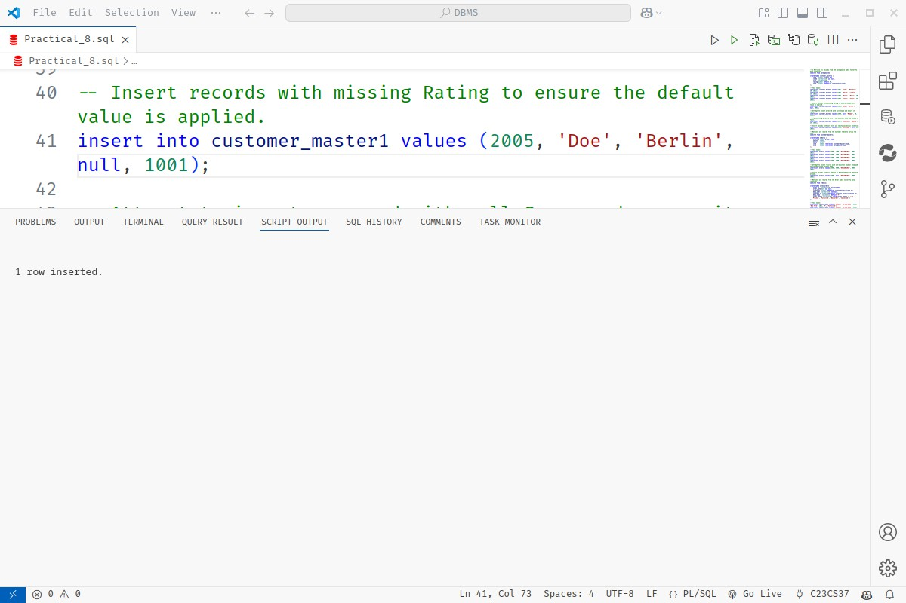



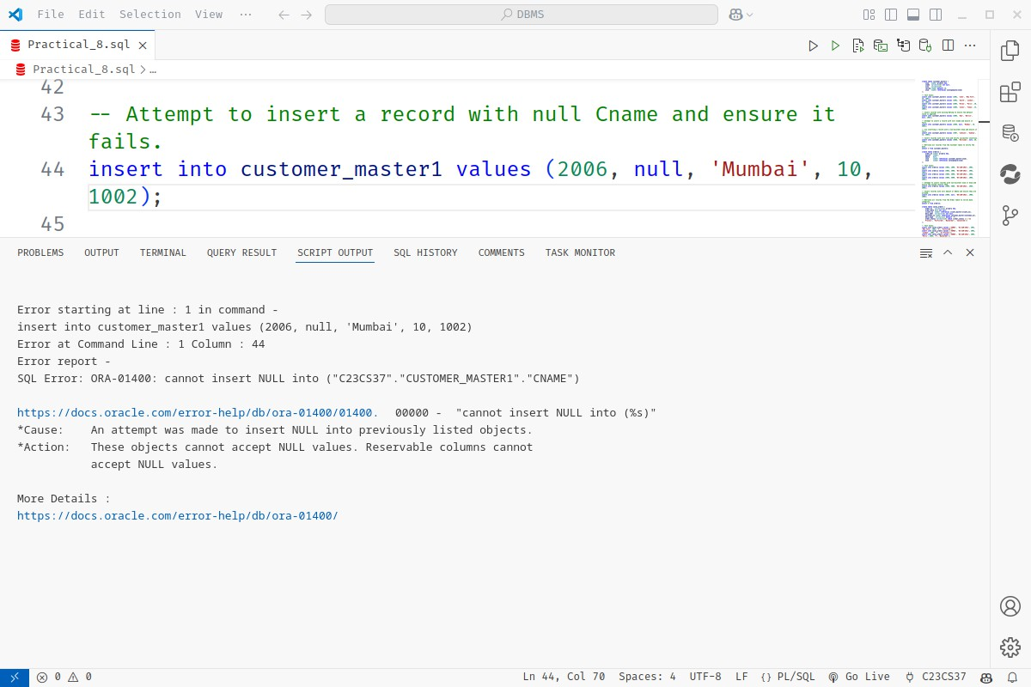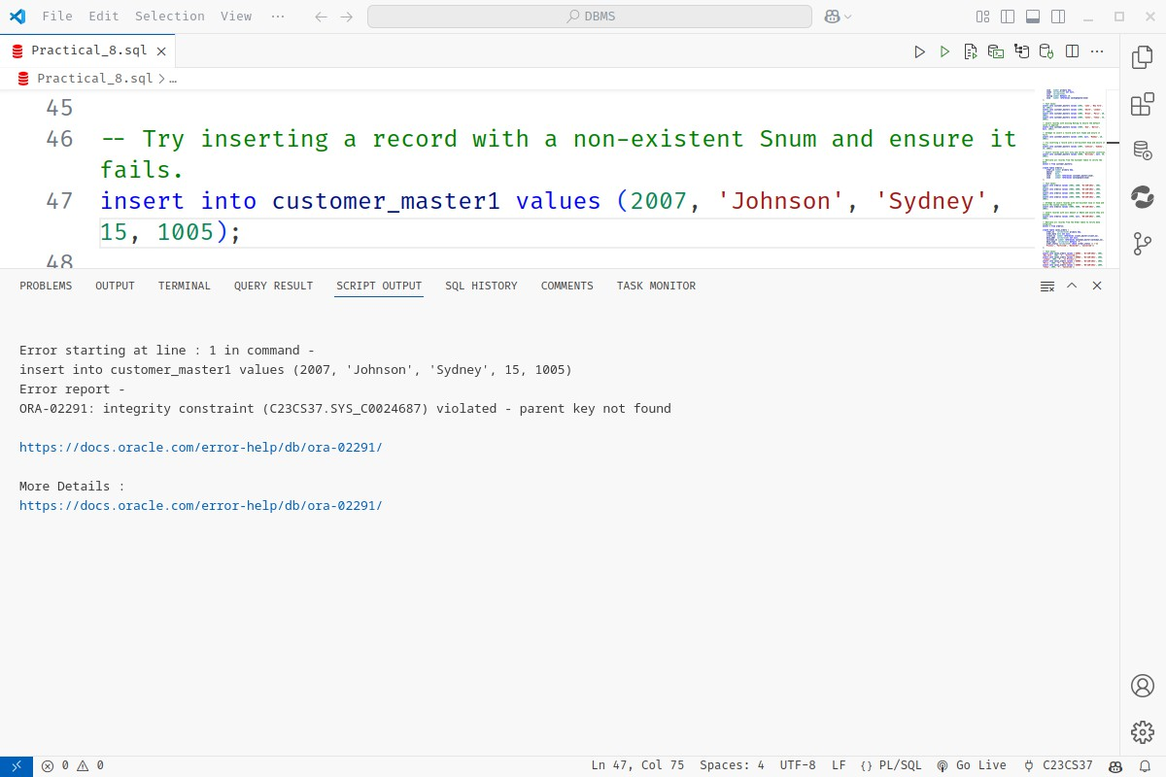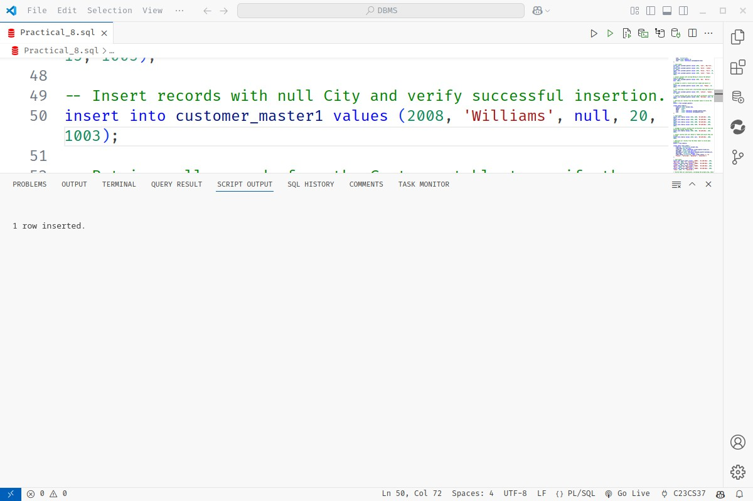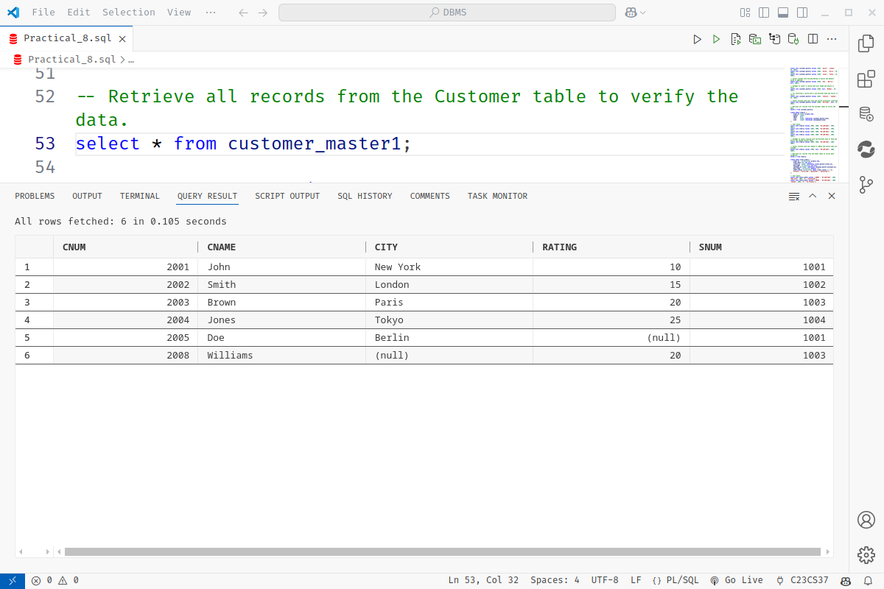





1. Managing Orders: The company tracks orders placed by customers, which are

****managed by salespeople.Each order has an ID, amount, date, and links to customers and salespeople.

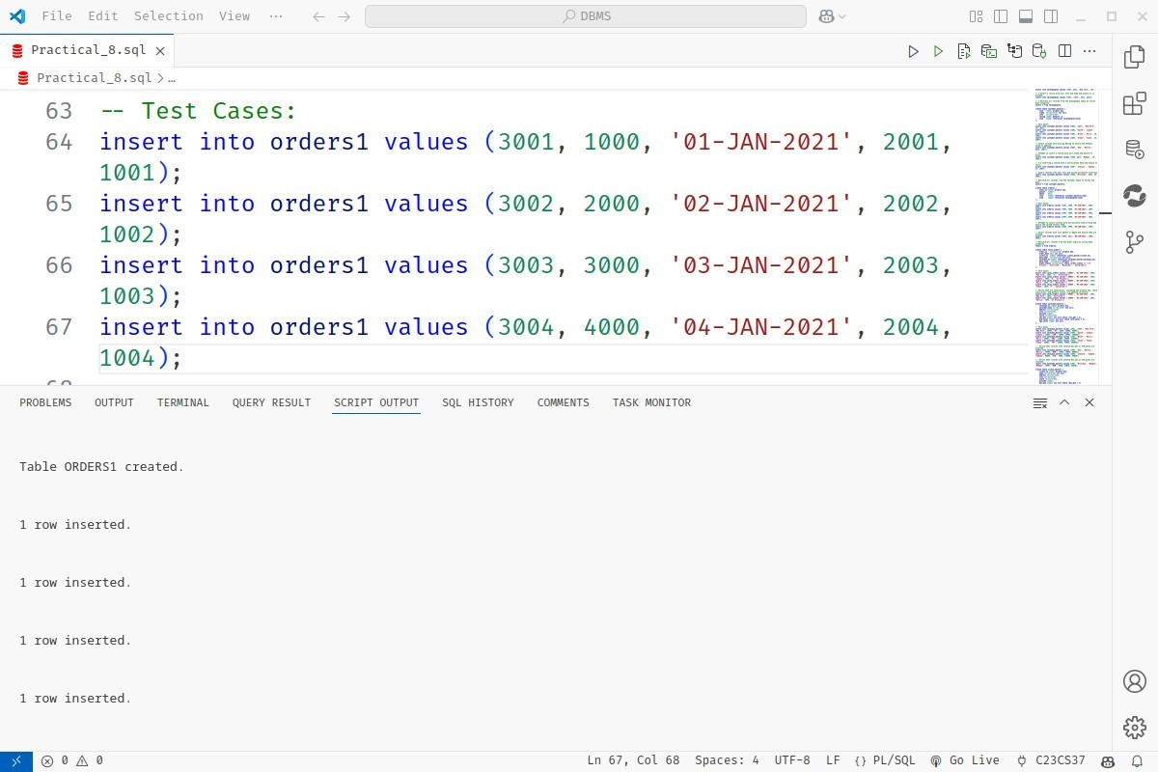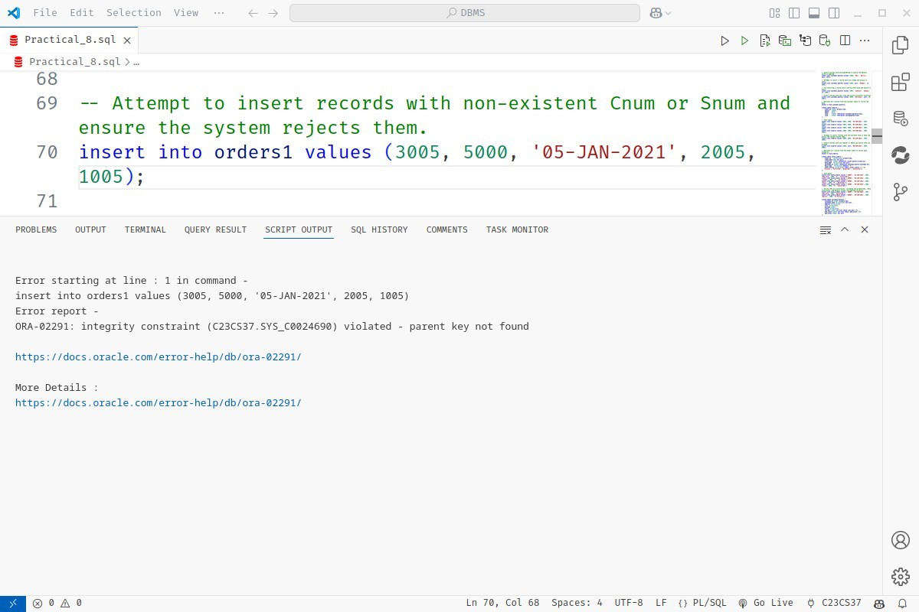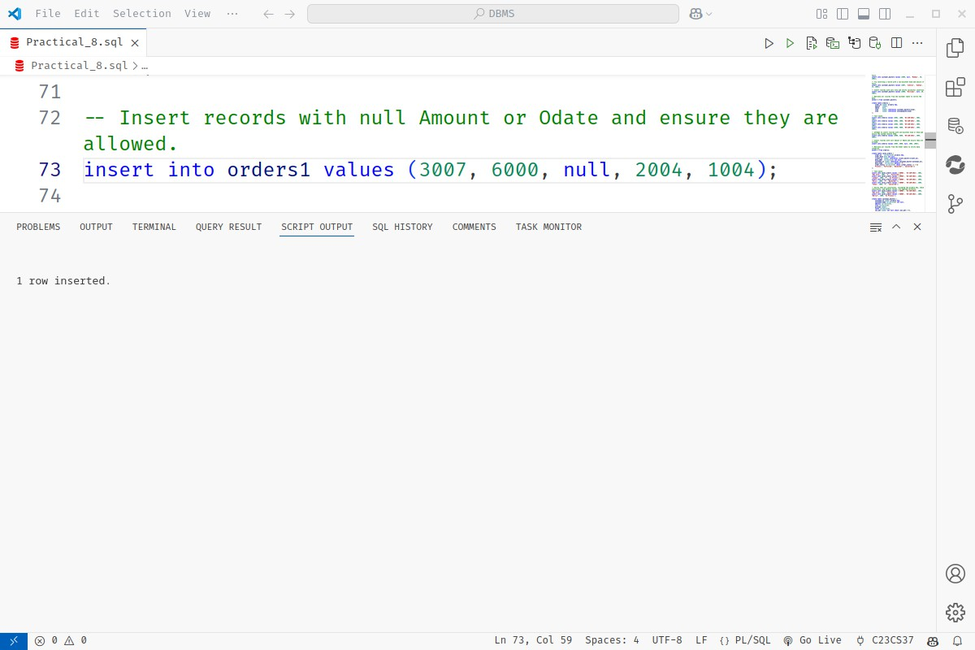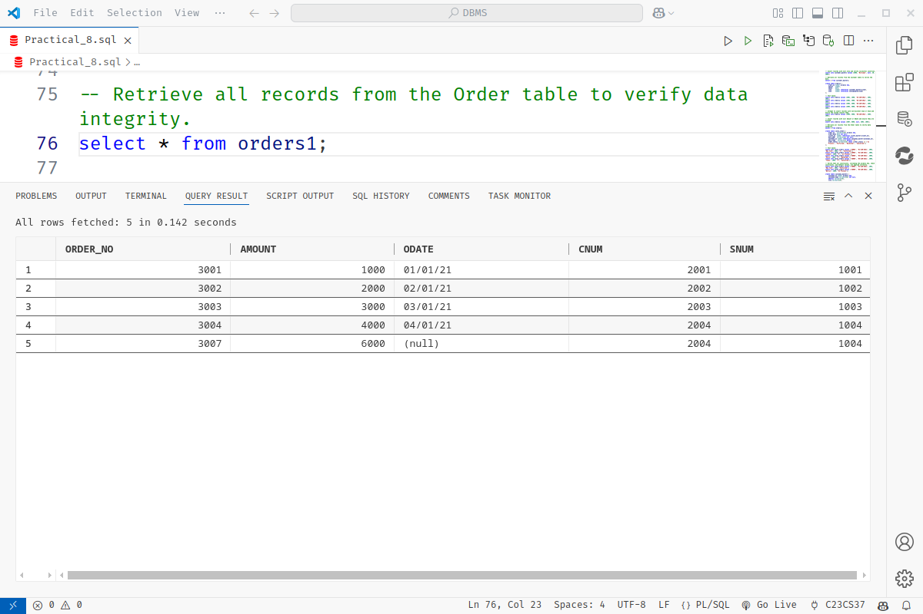





1. Managing Sales Orders: Sales orders track additional details such as delivery type

****and order status, with constraints to ensure consistency.

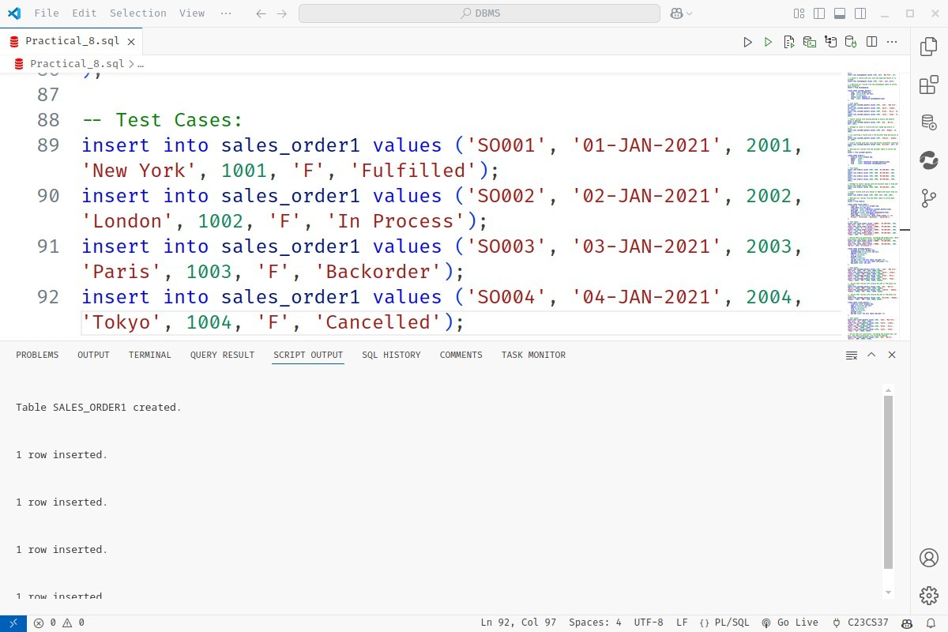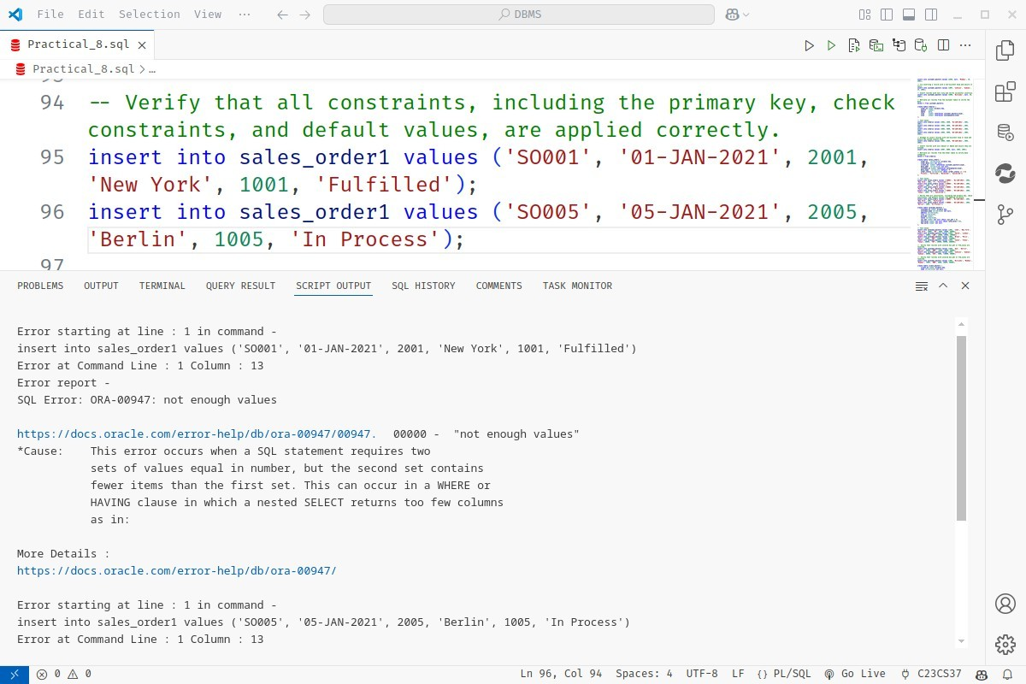

1. ****Managing Salesman Details: The organization needs to maintain records of salesmen, including their target and year-to-date sales, with strict constraints for validation.

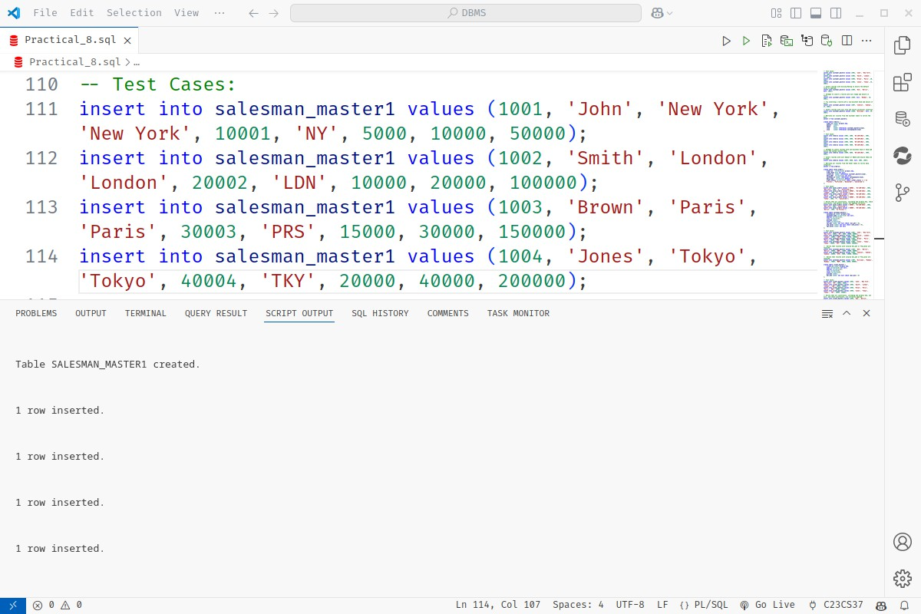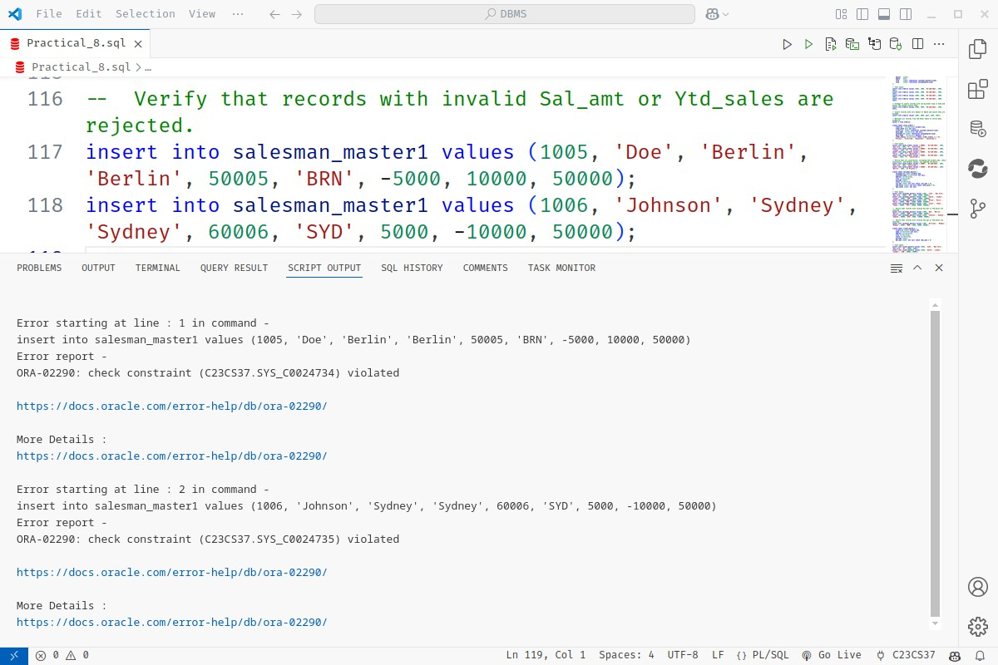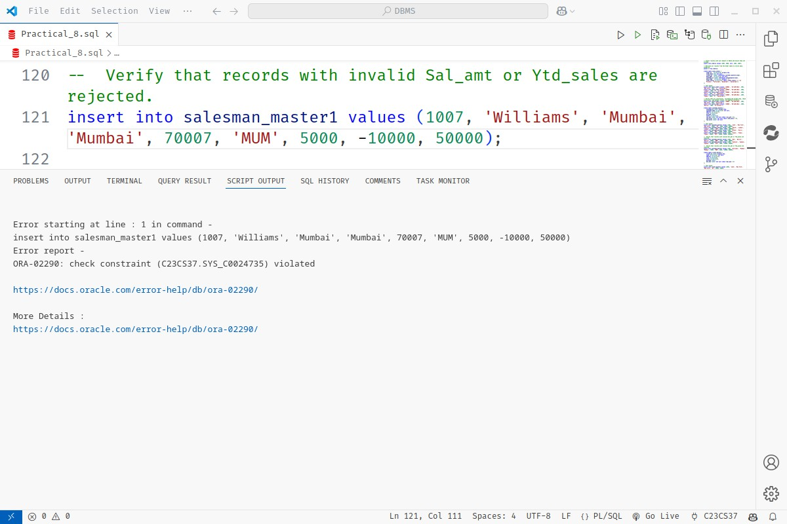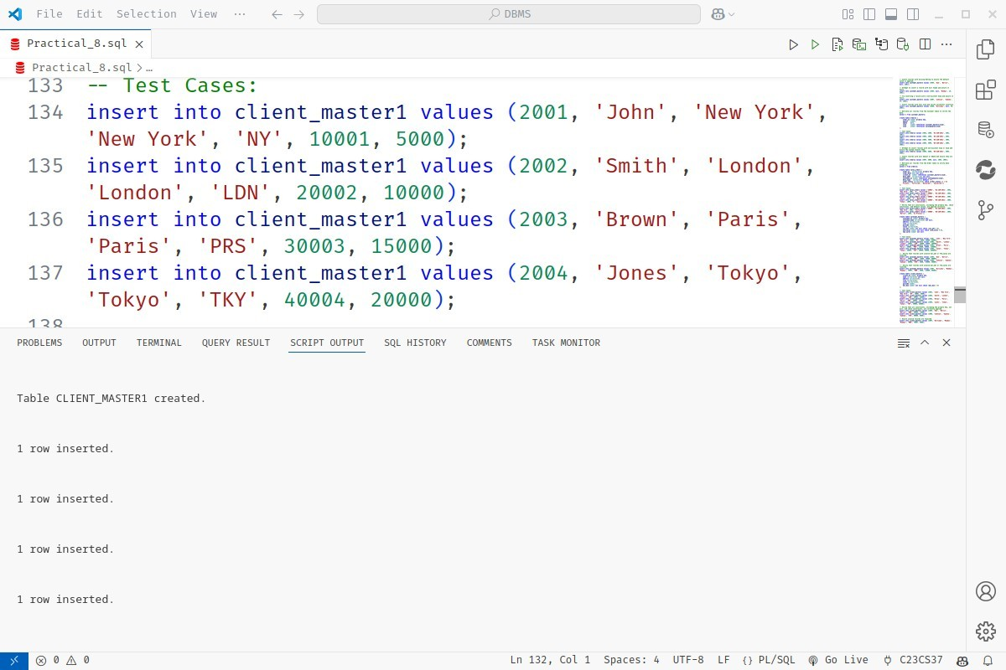



1. ****Managing Client Details: Clients are key stakeholders in the sales process. Their data must be consistent and adhere to specific constraints.



